Annotated Tag

What is Annotated Tag?
# Source: AI Source: Provided by: [Data Path: Persons Table -> ID Column: 1, Name_En Column: Motasem Essam] -> From: [ChatGPT] on [2/15/2026]
Annotated Tags in Git
An annotated tag is a full-featured tag in Git that stores extra information about a specific commit.
Think of it as a permanent label with metadata for a commit — often used for official releases.

Key points
# Source: AI Source: Provided by: [Data Path: Persons Table -> ID Column: 1, Name_En Column: Motasem Essam] -> From: [ChatGPT] on [2/15/2026]
- Contains metadata
  - Tagger name
  - Date
  - Optional message
  - Optional GPG signature for verification
- Stored as a Git object
  - Unlike lightweight tags, annotated tags are stored as full objects in Git
- Common use
  - Mark official releases: v1.0, v2.1.3
  - Keep a permanent record of milestones

How to create an annotated tag
# Source: AI Source: Provided by: [Data Path: Persons Table -> ID Column: 1, Name_En Column: Motasem Essam] -> From: [ChatGPT] on [2/15/2026]
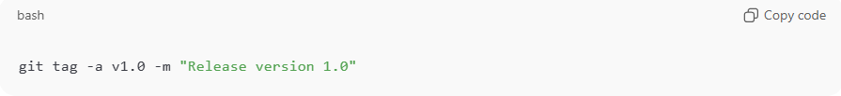
git tag -a v1.0 -m "Release version 1.0"
- -a → annotated
- -m → message describing the tag
You can also tag a specific commit:
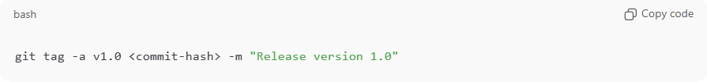
git tag -a v1.0 <commit-hash> -m "Release version 1.0"

How to view annotated tags
# Source: AI Source: Provided by: [Data Path: Persons Table -> ID Column: 1, Name_En Column: Motasem Essam] -> From: [ChatGPT] on [2/15/2026]
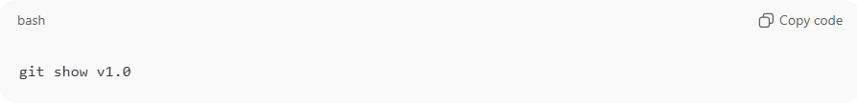
git show v1.0
- Displays:
  - Commit it points to
  - Tagger name
  - Date
  - Message

How to push annotated tags to remote
# Source: AI Source: Provided by: [Data Path: Persons Table -> ID Column: 1, Name_En Column: Motasem Essam] -> From: [ChatGPT] on [2/15/2026]
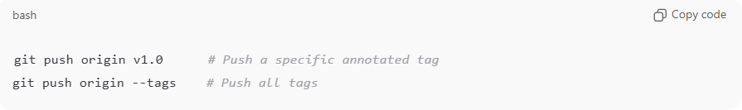
git push origin v1.0 # Push a specific annotated tag
git push origin --tags # Push all tags

Annotated vs Lightweight Tags
# Source: AI Source: Provided by: [Data Path: Persons Table -> ID Column: 1, Name_En Column: Motasem Essam] -> From: [ChatGPT] on [2/15/2026]
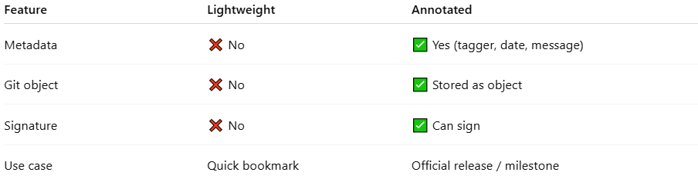
Feature | Lightweight | Annotated
Metadata | ❌ No | ✅ Yes (tagger, date, message)
Git object | ❌ No | ✅ Stored as object
Signature | ❌ No | ✅ Can sign
Use case | Quick bookmark | Official release / milestone

💡 Memory trick:
# Source: AI Source: Provided by: [Data Path: Persons Table -> ID Column: 1, Name_En Column: Motasem Essam] -> From: [ChatGPT] on [2/15/2026]
Annotated tag = permanent labeled commit → full info + optional signature → perfect for releases ✅

